Solution description document **- Assignment 3.2**

**1. Conceptual architecture of the distributed system**

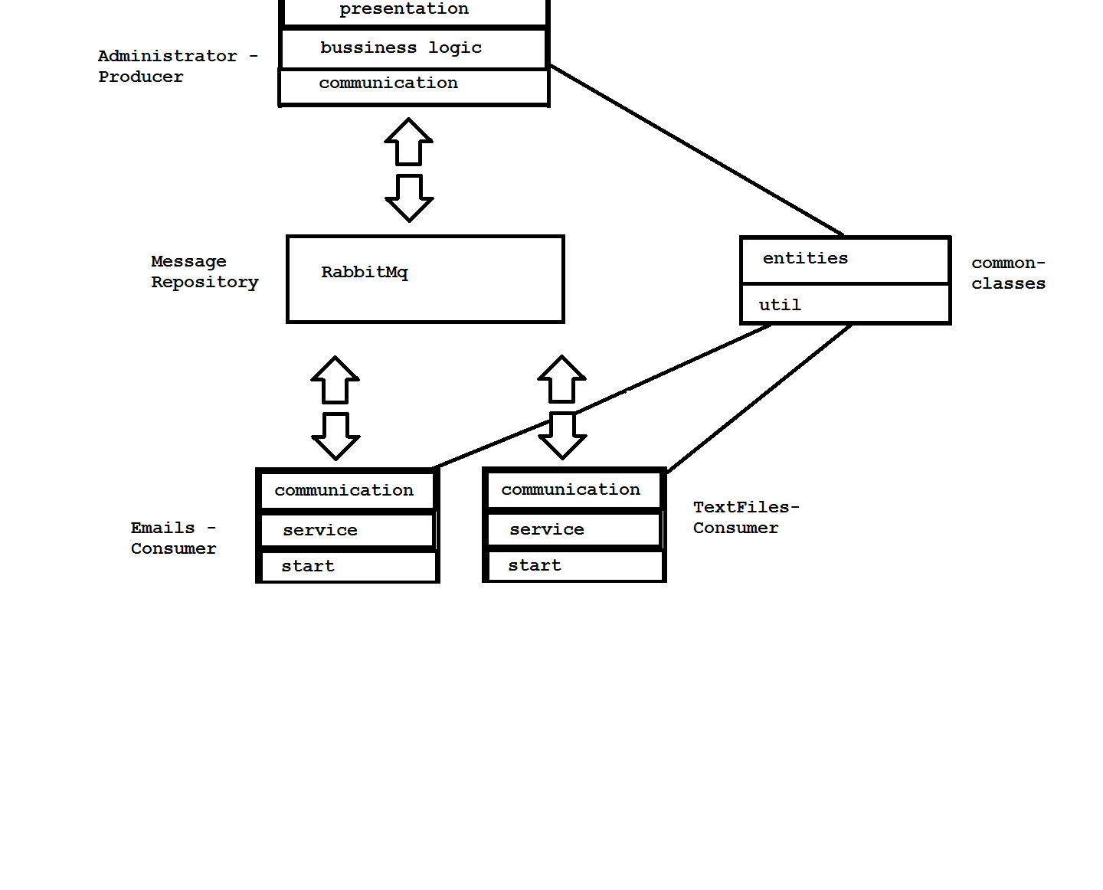

**2. Deployment diagram**

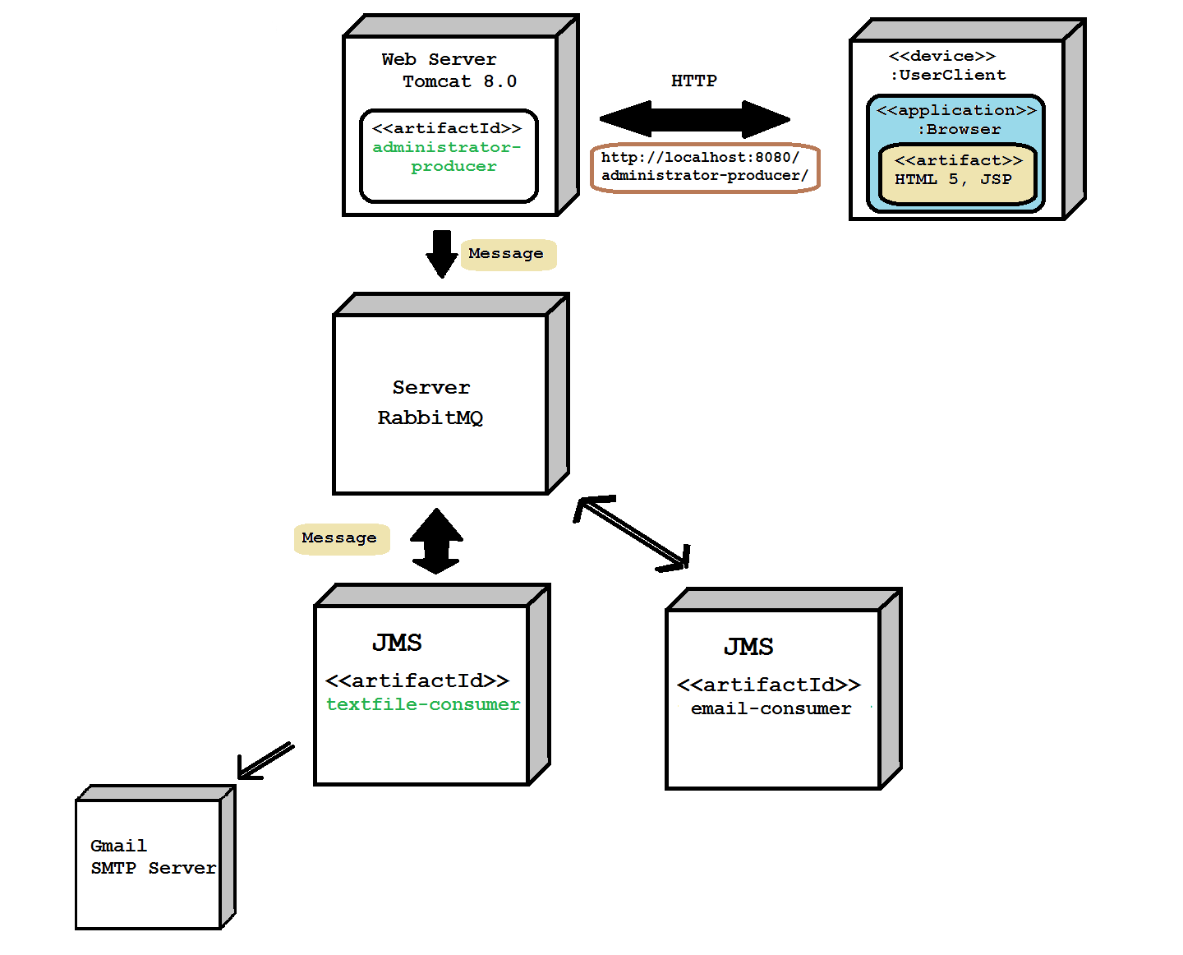

**3. Readme**

Build:

Administrator-Consumer

- deploy on Tomcat 8.0 server

Emails-Consumer and TextFiles-Consumer

- build as java application

- IDE(ex: Eclipse, Intellij etc.)

- JDK 1.8

- runtime environment: JRE 1.8

Run Steps:

- run Tomcat 8.0 server which contains administrator-consumer.war file

- run the client emails-consumer

- run the client textfiles-consumer